|  |
| --- |
|  |
| Faculty of Computers and Information Technology (FCIT) |
| Auto-attendance  Supervisor: Dr. Mohammad Naif Al-Atawi |
| Submitted in partial fulfilment of the requirements for the Degree of Bachelor of Computer Science |
| Academic Year: 2022/23 |

**Declaration of Originality**

This project is all my work and has not been copied in part or whole from any other source except where duly acknowledged. As such, all use of previously published work (from books, journals, magazines, the internet, etc.) has been recognised within the main report to an entry in the References list.

I agree that an electronic copy of this report may be stored and used for plagiarism prevention and detection.

I understand that cheating and plagiarism constitute a breach of University Regulations and will be dealt with accordingly.

Signed: Date:

**Office Stamp**

**Copyright**

The copyright of this project and report belongs to the University of Tabuk.

# Abstract

It is a mobile app for phones that facilitates many things that used to take much Time for the Student and the Lecturer, and its primary goal is to facilitate. Facilitate attendance and the absent and other items such as knowing the locations of the halls and teachers for each college and lecture to facilitate attendance in the fastest way to the hall or connected to the teachers' offices‏

every Student has the UniFinder app, and every hall has an ibeacon that holds the lecture info and hall number lecturer that is added to his student schedule. The ibeacon will sense the Student who has the UniFinder app and match his University ID to the Student of this current lecture. If University 10 matches the Student of this current lecture, then his (present); if not, send a notification. This hall does not match your Course.

# Table of Contents

Abstract 3

Table of Contents 4

Additional Materials on the Accompanying CD 5

List of Table 6

List of Figures 7

List of Abbreviations 8

Acknowledgements 9

1. Introduction 10
   1. Background to the Project 10
   2. Project Objectives 10
   3. Aims and Objectives 10

1.3.1 Advantage 10

1.3.2 Drawback 11

1. Investigation 12
   1. Tragging 12
   2. TimeCamp 13
   3. Bonsai 13
   4. Odoo 14
   5. Menaitech 14
2. Methodology 16
3. Requirements 17
   1. Functional Requirements 17
   2. Non-Functional Requirements 18
4. Analysis 19
   1. Use Case Diagram 19
   2. Sequence Diagram 20
   3. Activity Diagram 21
5. Design 22
   1. Entity Relationship Diagrams 22
   2. Data Dictionary Design 23

Bibliography and References 25

## Additional Materials on the Accompanying CD

|  |  |  |  |
| --- | --- | --- | --- |
| **List of Table** |  | | |
| **TABLE** | **TITLE** | **PAGE** |  |
| Table 1. Comparison with related systems |  |  | 15 |
| Table 2. Admin |  |  | 23 |
| Table 3. Staff info |  |  | 23 |
| Table 4. Teacher |  |  | 23 |
| Table 5. Student |  |  | 23 |
| Table 6. Department |  |  | 23 |
| Table 7. Hall Details |  |  | 24 |
| Table 8. Hall |  |  | 24 |
| Table 9. Schedule |  |  | 24 |
| Table 10. Ibeacon |  |  | 24 |

# List of Figures

#### FIGURE TITLE PAGE

Figure 1. Tragging app 12

Figure 2. TimeCamp App 13

Figure 3. Bonsai website 13

Figure 4. odoo website. 14

Figure 5. Water Fall Stages 16

Figure 6. Ibeacon operation 17

Figure 7. use case Diagram 19

Figure 8. Sequence Diagram 20

Figure 9. Activity Diagram 21

Figure 10. ER Diagrams 22

# List of Abbreviations

CS Computer Science

# Acknowledgements

We want to thank everyone who contributed to the successful completion of this project. We want to express our gratitude to our research supervisor, Dr. Muhammad Nayef Al-Atwi, for his invaluable advice, guidance and enormous patience throughout the research development.

In addition, we would also like to express our gratitude to our loving parents and friends who helped and encouraged us.

# Introduction

In the beginning, let us review the problems, how much the Lecturer loses time for attending, and sometimes he mistakes another Student, but our project idea can solve it. What about the Students They mistake things that the project can solve, such as what is the right hall, and is that my Course, if the project has rich for the highest compilation, we can use it for things other than the university, such as Cafés, restaurants and touristic places, this project can have many ideas involving (area information, and sending it for the user).

## Background to the Project

Given the importance of time for the student and the teacher and to take the maximum educational attainment.

Our project focuses on saving time and facilitating many steps.

## Project Objectives

• Speed of attendance and absence

• Find out where the halls are

• Knowing where the teachers are

**Problem overview:**

* The college needs a way to facilitate the status of attendance and absence.
* The students, the teachers, and visitors may have difficulty finding the halls.
* The teacher loses 5-10 min to take attendance.
* The teacher may conflict with Student's names.

**1.3 Aims and Objectives**

Therefore, we are working on an application for university students to facilitate the connection and save Time for students to find halls and teachers.

Auto-attendance and timer for the duration of the Student's attendance of the lecture.

Our system will save the teacher and student time. Also, the conflict with Student's name will not be an issue.

**1.3.1** Advantages

• 1- Attendance and absence for all students automatically.

• 2- Temporary for the duration of the student's lecture attendance.

• 3- Hall status, is there a lecture or not.

• 4- Fetching the information of the current hall, for example (the lecturer, the Lecturer start timer)

• 5- Hall dates and locations.

• 6- Print the student attendance record for only the lecturer.

1.3.2 Drawbacks

• The Cust of Ibecon

• Does not specify the time if the Ibecon didn't indicate the student.

• If the student has his phone turned off, then his absent.

• If the student has his phone turned off in the middle of class time, it will show less attendance time in state time.

## Overview of This Report

In addition to the current chapter, the report consists of nine other chapters:

* Chapter 2 presents the investigation.
* Chapter 3 presents the methodology.
* Chapter 4 presents the requirements.
* Chapter 5 depicts the analyses of the system.
* Chapter 6 describes the design of the system.
* Chapter 7 presents the implementation.
* Chapter 8 presents the conclusions.

# Investigation

We investigated many of the similar systems available on the web platform. We discovered several systems that offer a similar system tapproachrough the web platform—analysed based on the observation.

## Tragging

Where’s My Staff is a smartphone app developed by Trigging Company to help managers keep track of their employees during working hours. Office spaces and buildings

Our application is distinguished by the presence and absence of features [1].

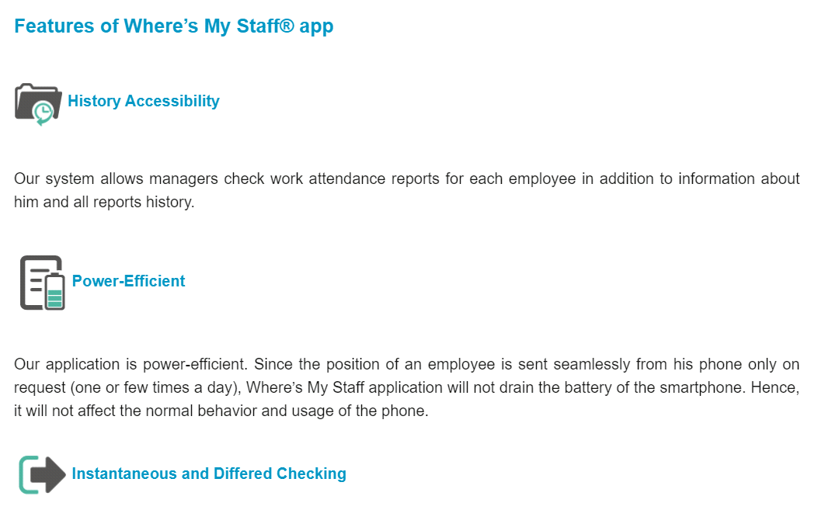

**Figure 1.** Trigging app

## TimeCamp

TimeCamp is a presence for employees and students but lacks many basic features, the most important of which are tracking, offices and places of presence [2.

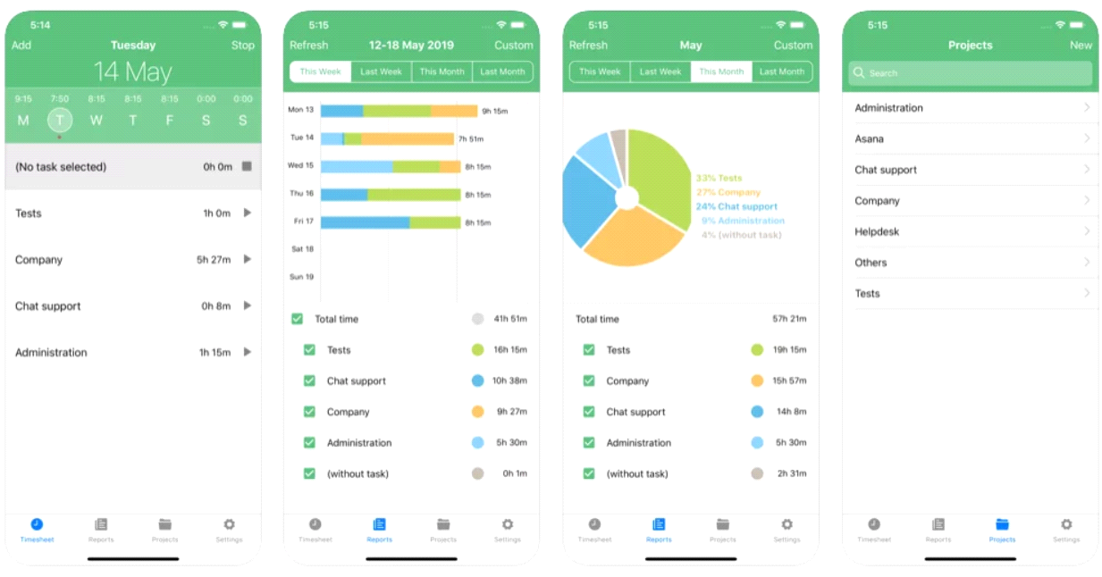

**Figure 2.** TimeCampApp

## Bonsai

Bonsai is a set of tools for employees to manage attendance, and we are distinguished from it by the hall locations and making it available for students, not just employees and teachers [3].

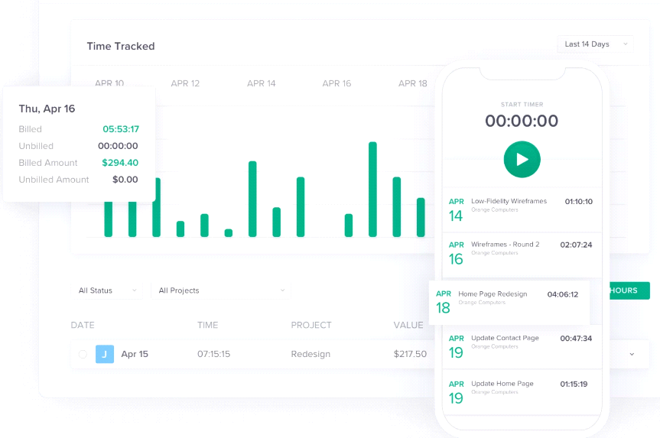

**Figure 3. Bonsai website**

## 

## Odoo

This site has some points similar to our program, such as attendance management, but it lacks some features, such as where the employee is located [4].

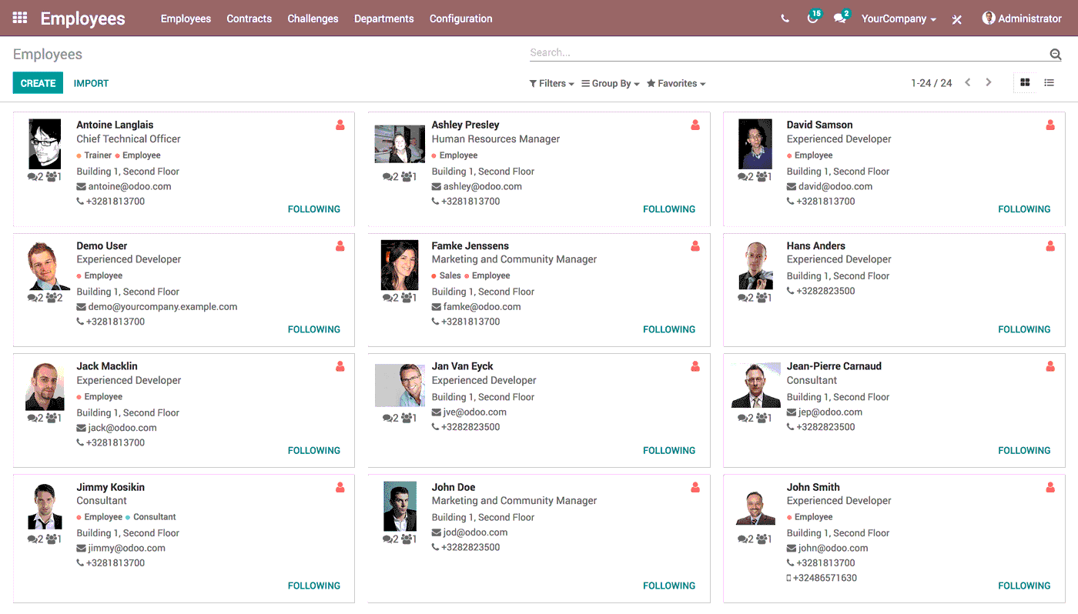

**Figure 4.** odoo website.

## Menaitech

This application is similar to our application, but it does not have options to adjust times and other options such as delay, and also, there is no option for the hall’s location.

**Table 1. Comparison with related systems**

|  |  |  |  |  |  |
| --- | --- | --- | --- | --- | --- |
| **Features** | **System** | | | | |
| Tragging | **TimeCamp** | **Bonsai** | **Odoo** | **Menaitech** |
| **Web platform** | **✅** | **✅** | **✅** | **✅** | **✅** |
| **Free trial** | **❎** | **❎** | **✅** | **✅** | **✅** |
| **stability** | **✅** | **✅** | **✅** | **✅** | **✅** |
| **Arabic language** | **✅** | **❎** | **❎** | **✅** | **✅** |

# Methodology

This project will use the waterfall methodology. The waterfall method is a project management approach that emphasises a linear progression from the beginning to the end of a project. Engineers often use this memethodologynd and are front-loaded to rely on careful planning, detailed documentation, and consecutive execution.

The Waterfall process usually includes stages [5]:

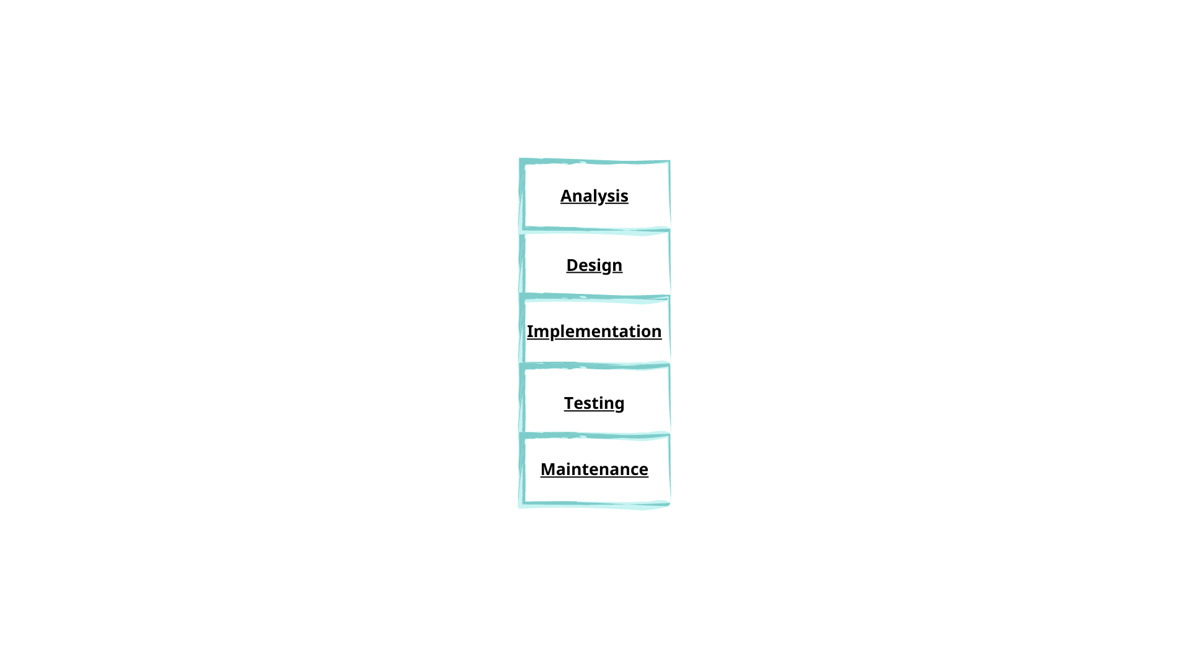

**Figure 5.** Water Fall Stages

**Analysis:**

The Waterfall methodology depends on the belief that all project requirements can be gathered and understood upfront. The project manager does their best to get a detailed understanding of the project sponsor’s requirements. Written requirements, usually contained in a single document, describe each stage of the project, including the costs, assumptions, risks, dependencies, success metrics, and timelines for completion.

**Design:**

Software developers design a technical solution to the problems set out by the product requirements, including scenarios, layouts, and data models. First, a higher-level or logical design is created that describes the purpose and scope of the project, the general traffic flow of each component, and the integration points. Once complete, it is transformed into a physical design using specific hardware and software technologies.

**Implementation:**

Once the design is complete, technical implementation starts. In this phase, programmers code applications based on project requirements and specifications, with some testing and implementation also taking place.

**Testing:**

Testing must ensure the product has no errors, and all requirements have been completed, providing a good user experience with the software. The testing team will turn to the design documents, personas, and user case scenarios supplied by the product manager to create their test cases.

**Maintenance:**

Once the software has been deployed in the market or released to customers, the maintenance phase begins. As defects are found and change requests come in from users, a team will be assigned to take care of updates and release new software versions [6].

# Requirements

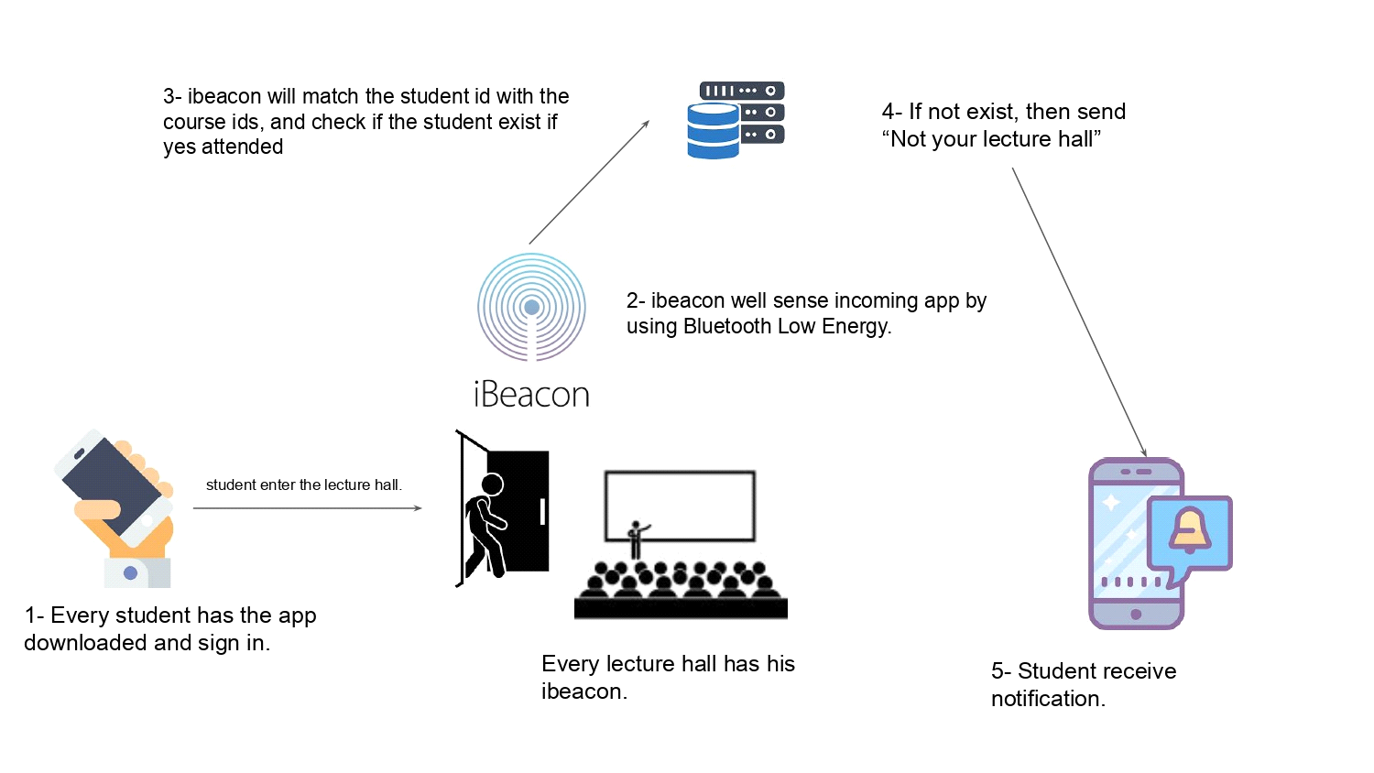

**Figure 6.** Ibeacon operation

## Functional Requirements

Functional requirements are product features or functions that developers must implement to enable users to accomplish their tasks. This system has many functions lecturers that assist clinics with their processes and management.

For the software:

* Administrator controls the accounts of the Lecturer and the Student (Create, Modify, Delete).
* Administrator controls the Lecturer and (Creates, Modify, and Delete).
* Administrator controls the Student accounts (Create, Modify, Delete).
* Lecturer requests the auto-attendants.
* Lecturer requests to print the state of class (student’s attendance time, attendance and absence).
* Students request the hall name.
* Students request the current hall state, which is (the subject of the class, Time of the class).

For the handwear:

* We will use it in our system Ibeacon device.

## Non-Functional Requirements

The non-functional requirement is a requirement that specifies criteria that can be used to judge the operation of a system rather than specific behaviours [6]. The non-functional requirements that will be provided in this project are usability, which is a measure of how well a specparticularr in a specific context can use a product to effectively, efficiently and satisfactorily achieve a defined goal.

For the software:

We need to ask the company for permeation to find an Ibeacon device that allows us to program.

Connecting the ibeacon to the system coding.

Connecting the ibeacon to the database.

Building a server that holds all the students and lecturers.

For the hardware:

The cost of the ibeacon that we need every hall to have.

Ibeacon sensor range.

In case of hardware errors, we need to buy a new ibeacon.

Does the ibeacon stay on for timing the Student attended?

# Analysis

At this phase, we will use some of the Unified Modeling Languages (UML) in this project because of its great help in the analysis and documentation process. Using the schemes Case Diagram, Sequence Diagram, Activity Diagram and Class Diagram.

## Use Case Diagram

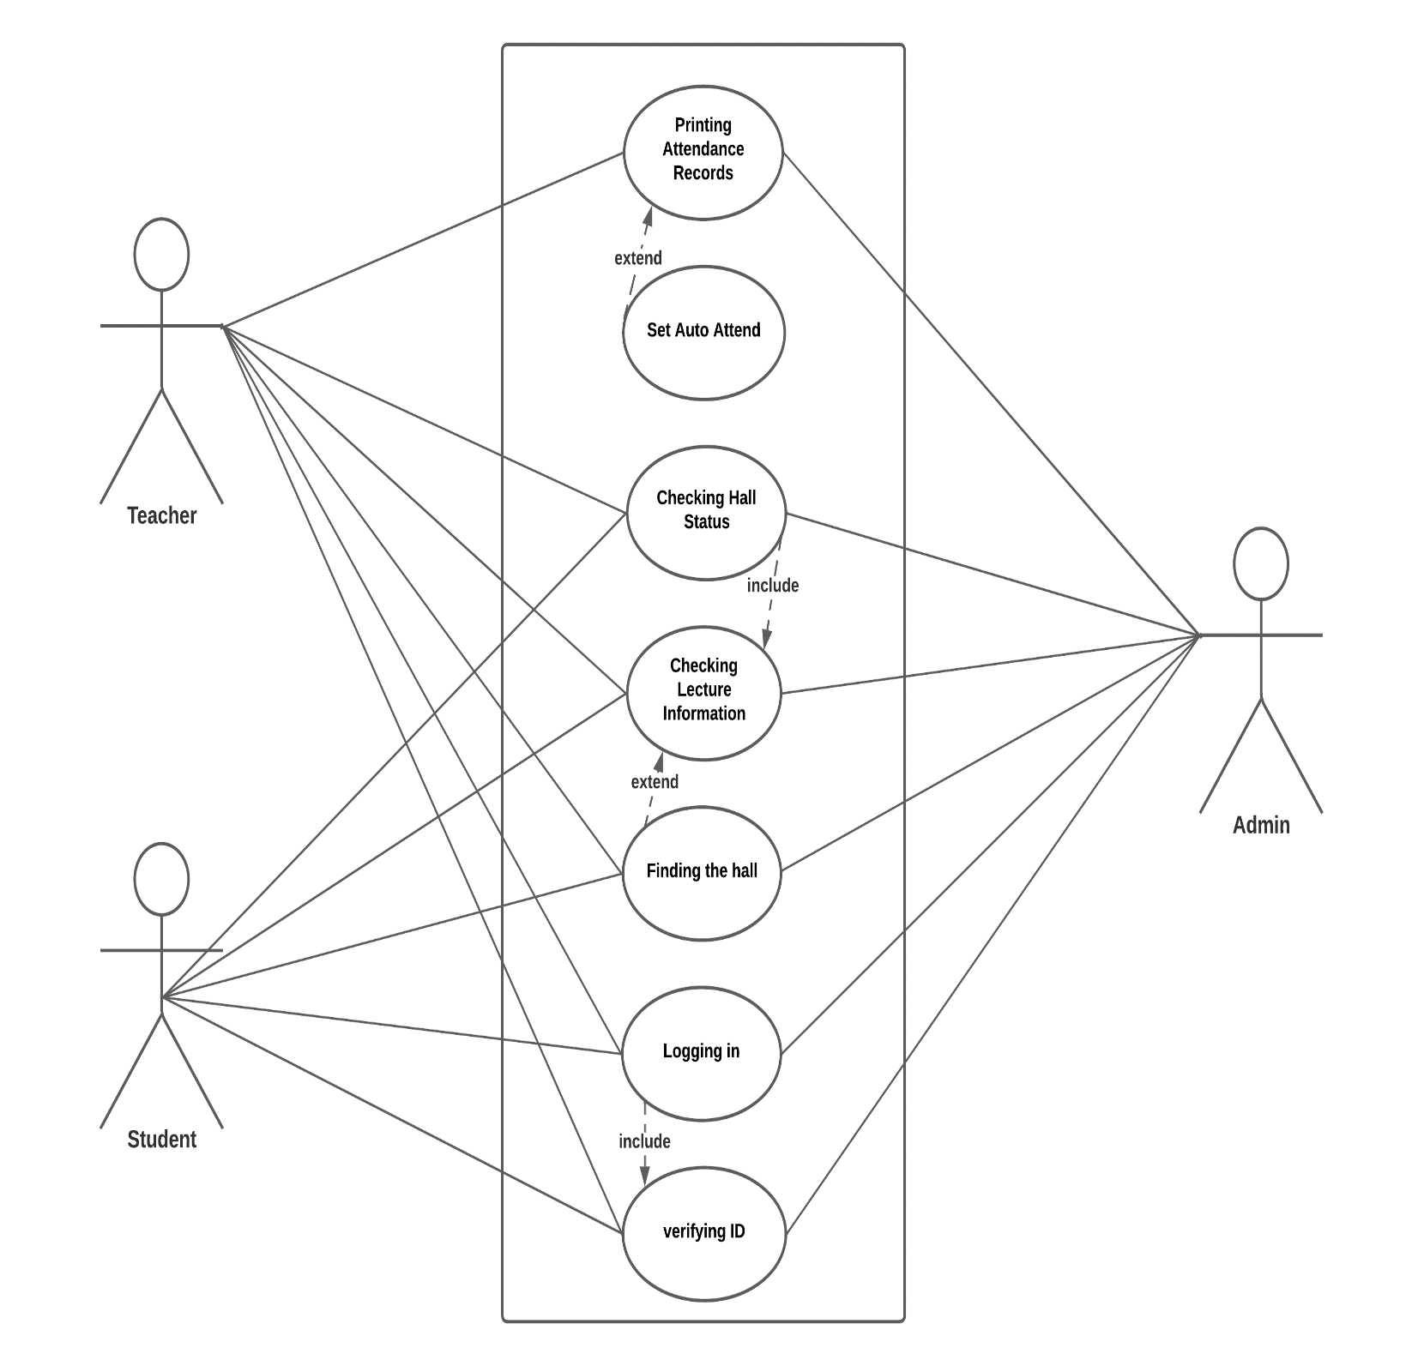

**Figure 7.** use case Diagram

## Sequence Diagram

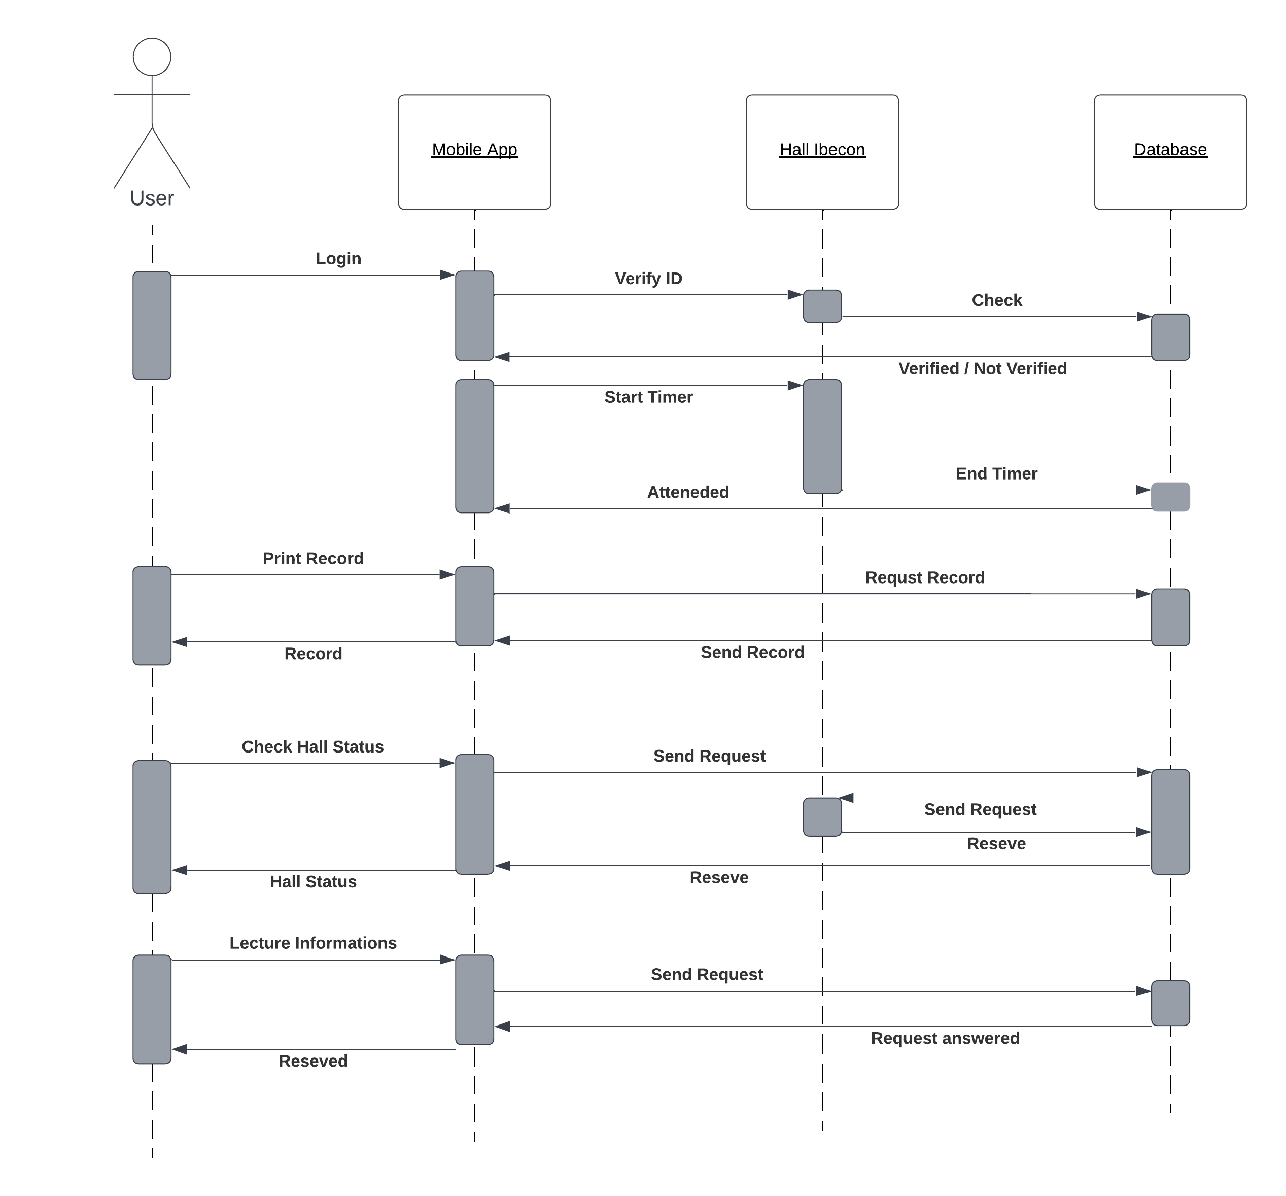

**Figure 8.** Sequence Diagram

## Activity Diagram

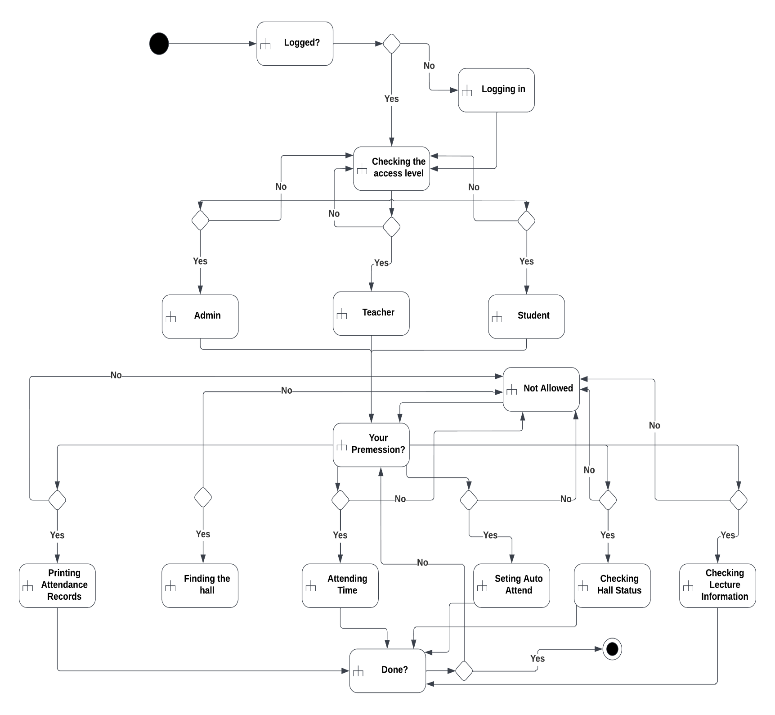

**Figure 9.** Activity Diagram

# Design

At this stage, we will present the entire system’s design through a diagram shown in the figure conceptual databases and relationships between objects in the system through the Entity Relationship Diagram (ERD).

## Entity Relationship Diagrams

An entity relationship diagram (ERD) shows the relationships of entity sets stored in a database [10].

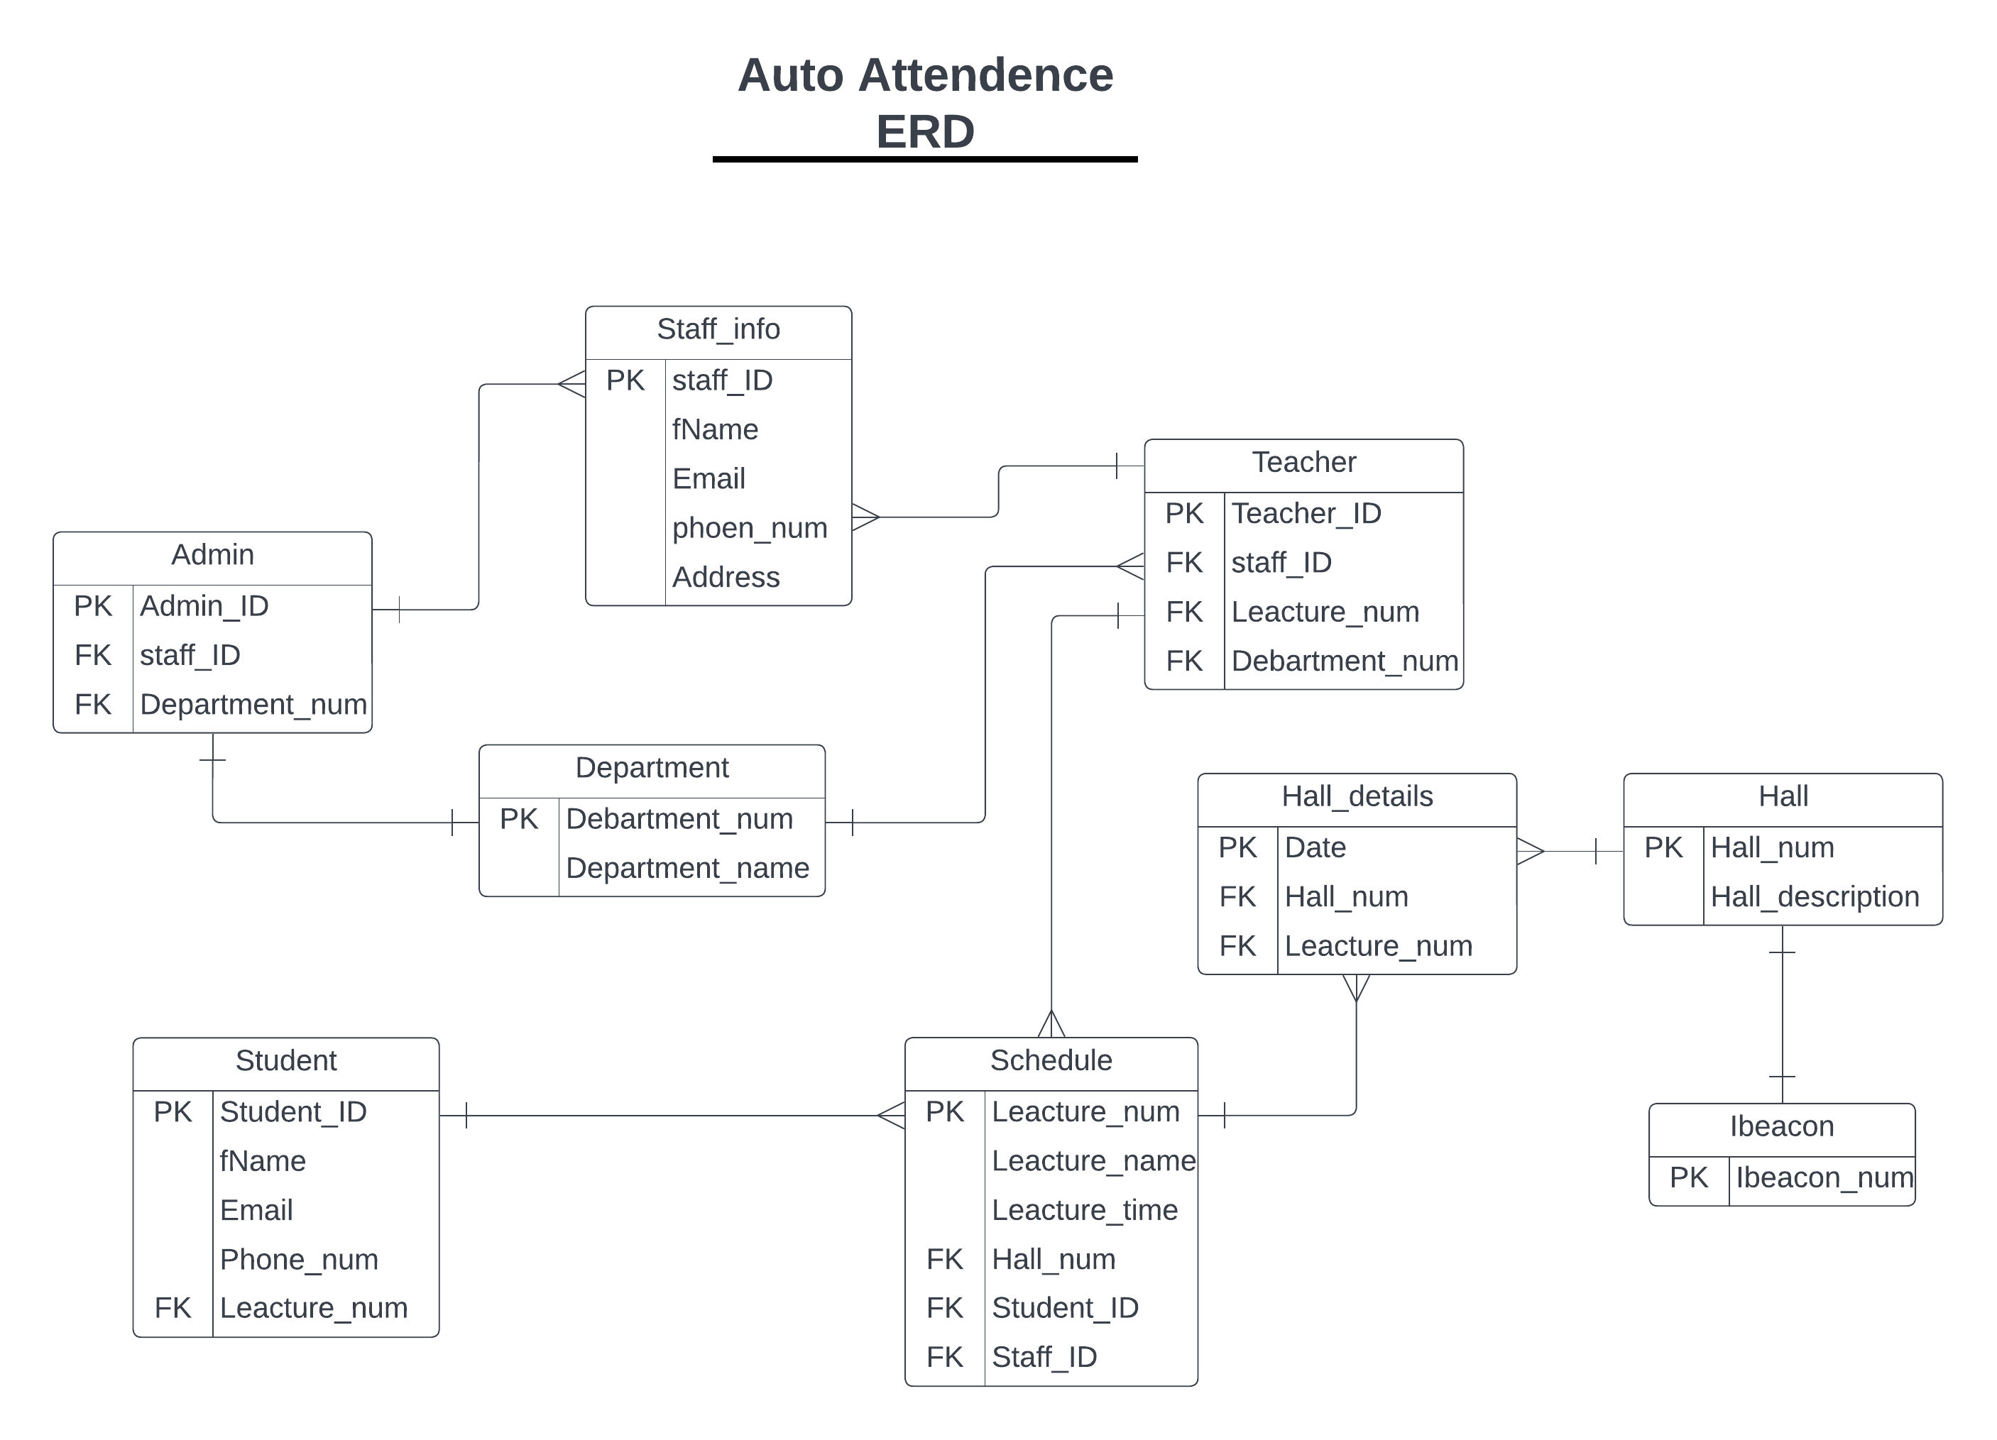

**Figure 10.** ER Diagrams

## Data Dictionary Design

The data dictionary is an inventory of data elements in a database or data model with a detailed description of its format, relationships, meaning, source and usage [7]. The data dictionary for the project is shown in the tables below.

**Table 2. Admin**

|  |  |  |
| --- | --- | --- |
| **Attribute** | **Type** | **Key** |
| Admin_ID | Int(7) | PK |
| Staff_ID | Int(10) | FK |
| Department_num | varchar(5) | FK |

**Table 11. Staff info**

|  |  |  |
| --- | --- | --- |
| **Attribute** | **Type** | **Key** |
| Staff_ID | Int(10) | PK |
| fName | varchar(50) |  |
| Email | varchar(25) |  |
| Phone_num | Int(10) |  |
| Address | Varchar(50) |  |

**Table 12. Teacher**

|  |  |  |
| --- | --- | --- |
| **Attribute** | **Type** | **Key** |
| Teacher_ID | Int(7) | PK |
| Staff_ID | Int(10) | FK |
| Leacture_num | varchar(7) | FK |
| Department_num | Int(5) | FK |

**Table 3. Student**

|  |  |  |
| --- | --- | --- |
| **Attribute** | **Type** | **Key** |
| Student_ID | Int(10) | PK |
| fName | varchar(50) |  |
| Email | varchar(25) |  |
| Phone_num | Varchar(10) |  |
| Lecture_num | Varcahr(7) | FK |

**Table 3. Department**

|  |  |  |
| --- | --- | --- |
| **Attribute** | **Type** | **Key** |
| Department_num | int(5) | PK |
| Department_name | varchar(25) |  |

**Table 15. Hall details**

|  |  |  |
| --- | --- | --- |
| **Attribute** | **Type** | **Key** |
| Date | Varchar(20) | PK |
| Hall_num | Int(5) | FK |
| Leacture_num | varchar(7) | FK |

**Table 15. Hall**

|  |  |  |
| --- | --- | --- |
| **Attribute** | **Type** | **Key** |
| Hall_num | Int(5) | PK |
| Hall_description | varchar(50) |  |

**Table 15. Schedule**

|  |  |  |
| --- | --- | --- |
| **Attribute** | **Type** | **Key** |
| Leacture_num | Varchar(7) | PK |
| Leacture_name | Varchar(20) |  |
| Leacture_time | varchar(15) |  |
| Hall_num | Int(5) | FK |
| Student_ID | Int(10) | FK |
| Staff_ID | Int(10) | FK |

**Table 15. Ibeacon**

|  |  |  |
| --- | --- | --- |
| **Attribute** | **Type** | **Key** |
| Ibeacon_num | Int(10) | PK |